Coding and STEM Resources

Adams Elementary Library | Lori Edwards | ledwards@k12k.com
Jackson Elementary Library | Lindsey Golden | lgolden@k12k.com
Jefferson Elementary Library | Kristy Williamson-Jackson | kwilliamson-jackson@k12k.com
Johnson Elementary Library | Rebecca Thomasson | rthomasson@k12k.com
Kennedy Elementary Library | Lindsey McKinney | lmckinney@k12k.com
Lincoln Elementary Library | Krystal McReynolds | kmcreynolds@k12k.com
Roosevelt Elementary Library | Michelle Blanton | mblanton@k12k.com
Washington Elementary Library | Kim Bradley | kbradley@k12k.com
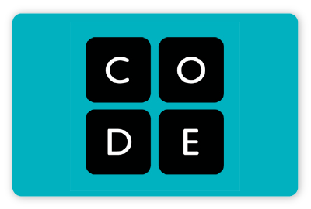

Code.org - Take a Code Break - Code.org is launching Code Break — potentially the world's largest live interactive classroom with weekly challenges to engage students of all abilities, even those without computers. Weekly activities and challenges.
https://code.org/break

You can also Take a Code Break by doing some of the fun Hour of Code activities! https://code.org/hourofcode/overview

Girls Who Code - Code at Home - Girls Who Code is making CS educational activities available for download free of charge, to anyone who wants to access them. We will release activities weekly — some online, some offline, of varying levels of difficulty—over the course of the next few months. Each activity will include a feature of a woman in tech who pioneered innovative technology.

https://girlswhocode.com/code-at-home/

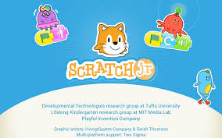
ScratchJr is an introductory programming language that enables young children to create their own interactive stories and games. Children snap together graphical programming blocks to make characters move, jump, dance, and sing. ... ScratchJr is available as a free app for both iPad and Android tablets or as an extension on Chromebooks.

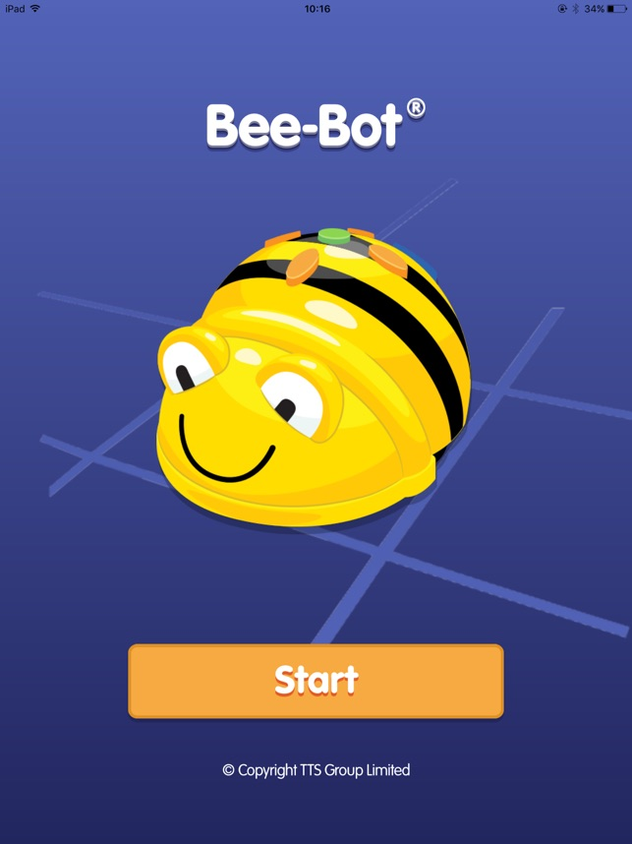
The app is a virtual opportunity to play with a Beebot, programming him to move across different pathways, based on the buttons children choose. The challenges get harder as children work through them. As with the physical Beebot toys there are lots of opportunities for children to communicate how they think they need to get the robot to where he needs to be. This app is available on both the App Store and Google Play.

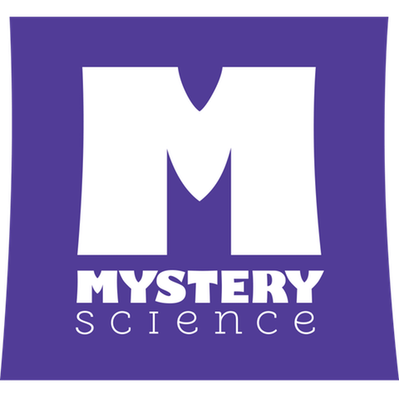

https://mysteryscience.com/school-closure-planning

NASA STEM @ Home For Students Grades K-4

